Typesetting Proof Checklist and Journal Article Template

All changes at this stage need to be within the bounds of reasonable revision (rather than writing a substantially different article). If a referee has recommended revisions, we suggest that you take their comments seriously and address their concerns as best as you can.
It is important that you thoroughly proofread and edit the final version of your article. Following is our recommended checklist to assist you in submitting the final version of your article for typesetting:
- Check spelling and punctuation line by line.
- Check names of authors and editors in the reference list and cross-check with citations within the body your article.
- Check the accuracy of citations, quotations, tables and captions to diagrams, illustrations and maps.
- Please provide tables using the Microsoft Word table menu.
- Please refrain from using Word Drawing objects. Figures should be in JPEG or PNG format only. The resolution of the figures should be 300 dpi.
- Please use Times New Roman throughout your article, including tables and figure captions. Do not use bold typeset to emphasize
- Please do not use page numbers as they will be set by our publishing staff.
Please find below a template to use for your final submission. Please note that the headers and footers will be updated by a member of our publishing staff when the article is typeset.

Journal Article Title: Subtitle

Author Name, University Affiliation, Country, E-mail
Author Name, University Affiliation, Country, E-mail
Author Name, University Affiliation, Country, E-mail

Abstract: Please insert the abstract here. To denote italicization in the abstract, please use double quotation marks. An example would be “The International Journal of the Book.”

Keywords: List of Keywords in Title Case, Commas in between, Keywords Should be Center Aligned
JEL Codes: …, …, …, ….
- Section Heading
The opening paragraph has no indentation. Your article’s format should follow the format of this template. To use the template, use the original Style Set that we have created for you, which you have downloaded by opening this sample template. The Style Set can be found in the upper right hand corner of the page under the tab “Home” and is listed as “Styles.” If you are using a separate Microsoft document than this one, please first save this style set to your computer by clicking on “Change Styles,” “Style Set,” and then “Save as a Quick Style Set.” Name the style set anything that you like (for example “JoYArticleStyleSet”) and then you will be able to access this style set from other Microsoft documents. To access the style set that you saved, click “Change Styles,” “Style Set,” and click on the set that you just saved. To determine which style is used in each section, click on the text in that section. For example, this section is using the “FirstParaOfSectionTextStyle.” Highlight the text that you would like to be formatted, and click on the corresponding Style, and the text will be changed automatically to format according to the style that you press. Please do not alter the margins.
Block quotations should be indented by .5 inches (1.27 cm.), should not include quotation marks, and should end with a parenthetical citation after the period. Block quotes should be used when quoting three or more lines. (Author Surname year published, page number when available)
The second and subsequent paragraphs in sections are indented by .25 inches (0.63 cm). Text should be single spaced, and spaces should only exist between paragraphs when using block quotes, as seen above.
- New Section Heading
The opening paragraph has no indentation.
The second and subsequent paragraphs in sections are indented by .25 inches (0.63 cm).
  - Section Subheading
The opening paragraph has no indentation.
The second and subsequent paragraphs in sections are indented by .25 inches (0.63 cm).
  - Section Subheading 2
The opening paragraph has no indentation.
The second and subsequent paragraphs in sections are indented by .25 inches (0.63 cm).
When inserting tables and figures within the body of the article, position them after the paragraph in which they are described. When citing the source information, it should be included at the bottom of the figure in a “source line.” Tables and figures should be labeled with numbers and a short, descriptive title. Table headings should be centered above the table, while figure captions should be centered below the image. Examples can be seen below in Table 1 and Figure 1.
Table 1. Title of Table
 | Column Title | Column Title | Column Title
Row Title
Row Title
Source(s): Data Adapted from Author’s Surname year of publication.

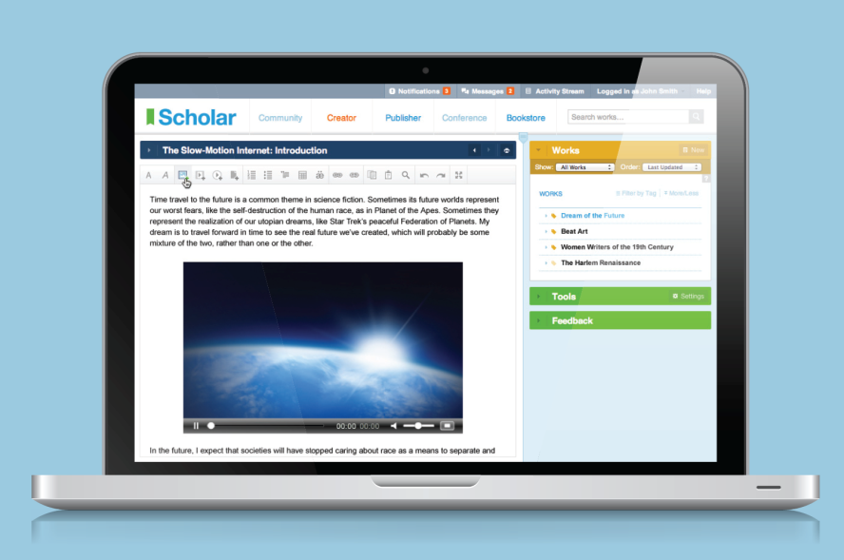
Figure 1. Caption of Figure Here
Source(s): Author’s Surname year of publication.
- Another Section Heading
- First Level
  - Second Level
    - Third Level

Acknowledgement
If including an acknowledgement, please insert it here.

REFERENCES
Insert reference list here. It should follow the Sixteenth Edition of The Chicago Manual of Style. In order to comply with The Chicago Manual of Style author-date system, we ask that references be formatted in alphabetical order, single spaced, and with a hanging indent. Formatting examples are below. In-text citations are like this (Pollan 2006, 99-100) when you want to reference specific pages in the text and like this (Pollan 2006, 99-100; Weinstein 2009) when a second text is being referenced and you don’t want to reference specific pages within the second text. More information on Chicago Manual of Style can be found at http://www.chicagomanualofstyle.org/tools_citationguide.html
Pollan, Michael. 2006. The Omnivore’s Dilemma: A Natural History of Four Meals. New York: Penguin.
Weinstein, Joshua I. 2009. “The Market in Plato’s Republic.” Classical Philology 104:439–58.

We accept only internal author-date citations. If you are using the footnote system, please make sure to use the footnote function on Microsoft Word (found under the references section) and to keep footnotes in size 8 font in Times New Roman.

